Support Vector Machine

Support Vector Machine (SVM) is a powerful machine learning algorithm used for linear or nonlinear classification, regression, and even outlier detection tasks.
Support Vector Machine (SVM) is a supervised machine learning algorithm used for both classification and regression. Though we say regression problems as well it’s best suited for classification.
The main objective of the SVM algorithm is to find the optimal hyperplane in an N-dimensional space that can separate the data points in different classes in the feature space.
The hyperplane tries that the margin between the closest points of different classes should be as maximum as possible.
The dimension of the hyperplane depends upon the number of features. If the number of input features is two, then the hyperplane is just a line.
If the number of input features is three, then the hyperplane becomes a 2-D plane. It becomes difficult to imagine when the number of features exceeds three.

Let’s consider two independent variables x₁, x_{2,} and one dependent variable which is either a blue circle or a red circle.
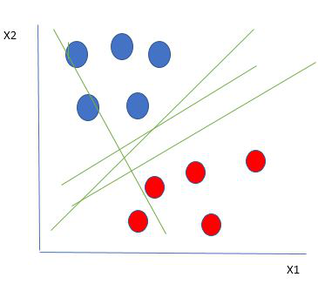

From the figure above it’s very clear that there are multiple lines (our hyperplane here is a line because we are considering only two input features x1, x2) that segregate our data points or do a classification between red and blue circles.

How does SVM work?
One reasonable choice as the best hyperplane is the one that represents the largest separation or margin between the two classes.

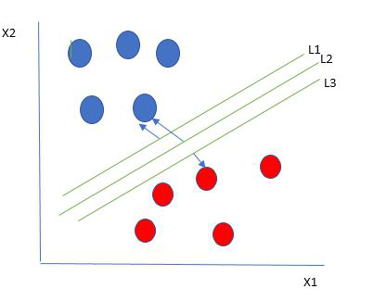
So we choose the hyperplane whose distance from it to the nearest data point on each side is maximized.
If such a hyperplane exists it is known as the maximum-margin hyperplane/hard margin.
So from the above figure, we choose L2. Let’s consider a scenario like shown below
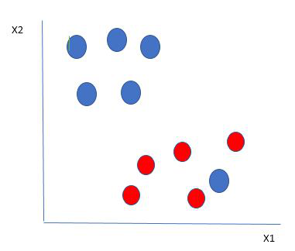
Selecting hyperplane for data with outlier
Here we have one blue ball in the boundary of the red ball. So how does SVM classify the data? It’s simple! The blue ball in the boundary of red ones is an outlier of blue balls. The SVM algorithm has the characteristics to ignore the outlier and finds the best hyperplane that maximizes the margin. SVM is robust to outliers.
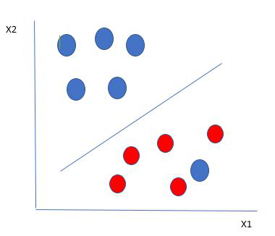
Hyperplane which is the most optimized one
So in this type of data point what SVM does is, finds the maximum margin as done with previous data sets along with that it adds a penalty each time a point crosses the margin.
So the margins in these types of cases are called soft margins.

What to do if data are not linearly separable?
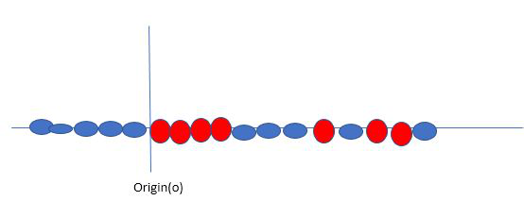
Say, our data is shown in the figure above. SVM solves this by creating a new variable using a kernel. We call a point x_{i} on the line and we create a new variable y_{i} as a function of distance from origin o.
so if we plot this we get something like as shown below
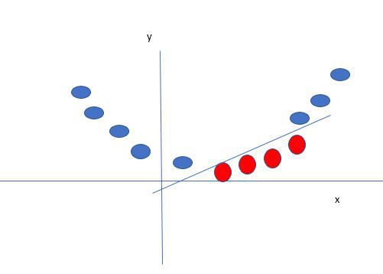
In this case, the new variable y is created as a function of distance from the origin.
A non-linear function that creates a new variable is referred to as a kernel.

Popular kernel functions in SVM
The SVM kernel is a function that takes low-dimensional input space and transforms it into higher-dimensional space, ie it converts nonseparable problems to separable problems.
It is mostly useful in non-linear separation problems.
Simply put the kernel, does some extremely complex data transformations and then finds out the process to separate the data based on the labels or outputs defined.
- Radial Basis function
- Linear
- Poly
- sigmoid

import pandas as pd
df = pd.read_csv("bangalore house price prediction OHE-data.csv")
df.head()

X = df.drop('price', axis=1)
y = df['price']

print('Shape of X = ', X.shape)
print('Shape of y = ', y.shape)

from sklearn.model_selection import train_test_split
X_train, X_test, y_train, y_test = train_test_split(X, y, test_size=0.2, random_state=51)

print('Shape of X_train = ', X_train.shape)
print('Shape of y_train = ', y_train.shape)
print('Shape of X_test = ', X_test.shape)
print('Shape of y_test = ', y_test.shape)

Feature Scalling
from sklearn.preprocessing import StandardScaler
sc = StandardScaler()
sc.fit(X_train)
X_train = sc.transform(X_train)
X_test = sc.transform(X_test)

from sklearn.svm import SVR

svr_rbf = SVR(kernel='rbf')
svr_rbf.fit(X_train, y_train)
svr_rbf.score(X_test, y_test)

using kernel linear
svr_linear = SVR(kernel='linear')
svr_linear.fit(X_train, y_train)
svr_linear.score(X_test, y_test)

using kernel poly
svr_poly = SVR(kernel='poly',degree=2,)
svr_poly.fit(X_train, y_train)
svr_poly.score(X_test, y_test)

now predict the price
svr_linear.predict([X_test[0]])

now preditct the all the test dataset price
y_pred = svr_linear.predict(X_test)
y_pred

y_test

now check there is any error using mse
from sklearn.metrics import mean_squared_error
import numpy as np

mse = mean_squared_error(y_test, y_pred)
rmse = np.sqrt(mse)

print('MSE = ', mse)
print('RMSE = ', rmse)

